1. **Role of a parser (diagram must)**

A parser is a software component that is responsible for analyzing and understanding the structure of code or data and converting it into a meaningful representation that can be used by other software components. The parser takes as input a stream of tokens generated by a lexical analyzer and generates a parse tree or an abstract syntax tree (AST). The roles of a parser can be summarized as follows:

1. Tokenization: The parser receives a stream of tokens from the lexical analyzer and groups them into meaningful sequences based on the syntax of the language being parsed.
2. Syntax analysis: The parser checks whether the sequence of tokens conforms to the syntax rules of the language being parsed. It identifies the syntactic structure of the code and creates a parse tree or AST to represent it.
3. Error handling: The parser detects and reports syntax errors, such as missing semicolons, unmatched parentheses, and incorrect use of operators. It provides useful feedback to the programmer to help them fix the errors.
4. Semantic analysis: The parser performs semantic analysis on the code, which involves checking for type errors, undeclared variables, and other semantic errors. It creates a symbol table to keep track of the variables, functions, and other symbols defined in the code.
5. Code generation: The parser generates intermediate code or machine code that can be executed by the computer. It optimizes the code by eliminating redundant instructions and rearranging them for better performance.

Here is an explanatory diagram that shows the role of a parser in the overall process of compiling a program:

Source code --> Lexical analyzer --> Tokens --> Parser --> Parse tree/AST --> Semantic analyzer --> Intermediate code --> Machine code --> Executable code

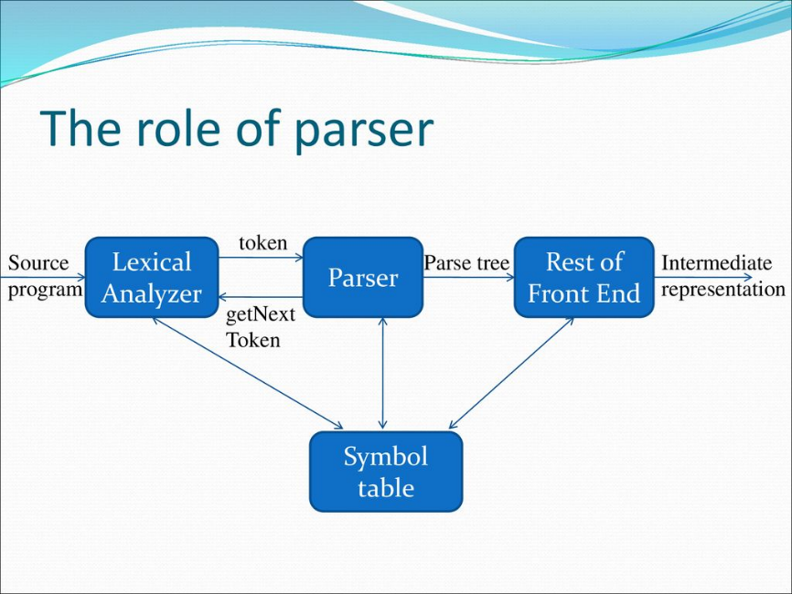

In this diagram, the source code is first fed into a lexical analyser, which generates a stream of tokens. The parser then processes the tokens and generates a parse tree or AST. The semantic analyser checks the parse tree or AST for semantic errors and generates intermediate code. The code generator then produces machine code from the intermediate code, which can be executed by the computer.

1. **Explain briefly about leftmost derivation, right most derivation ,top down parser ,bottom up parser (theory) and also rules for first and follow functions(well-structured and SMART)**

Leftmost Derivation and Rightmost Derivation: A derivation is a sequence of rewrite rules applied to a start symbol to generate a string of terminals. A leftmost derivation is one in which the leftmost non-terminal in each production is expanded first. A rightmost derivation is one in which the rightmost non-terminal in each production is expanded first. These are used in parsing algorithms to derive parse trees and parse the input.

Top-Down Parser: A top-down parser starts at the root of the parse tree and works its way down to the leaves. It uses a grammar and input string to recursively apply production rules to generate a parse tree. The most common types of top-down parsers are Recursive Descent and LL(1) parsers.

Bottom-Up Parser: A bottom-up parser starts at the leaves of the parse tree and works its way up to the root. It uses a grammar and input string to build the parse tree from the bottom up by applying production rules in reverse order. The most common types of bottom-up parsers are LR and LALR parsers.

First and Follow Functions: The first and follow functions are used in parsing algorithms to predict which production rule to apply in a given situation. The first function returns the set of terminals that can appear as the first symbol in a string derived from a non-terminal. The follow function returns the set of terminals that can appear immediately after a non-terminal in a derivation.

Rules for First Function:

* If X is a terminal, First(X) = {X}
* If X -> ε is a production rule, add ε to First(X)
* If X -> Y1Y2...Yk is a production rule, add First(Y1) to First(X). If First(Y1) contains ε, add First(Y2) to First(X), and so on, until First(Yk) is added or ε is not in First(Yi) for any i.

Rules for Follow Function (Well-Structured):

* Follow(S) = {$} (where S is the start symbol)
* If there is a production A -> αBβ, then everything in First(β) except for ε is in Follow(B)
* If there is a production A -> αB, or a production A -> αBβ where ε is in First(β), then everything in Follow(A) is in Follow(B).

Rules for Follow Function (SMART):

* Follow(S) = {$} (where S is the start symbol)
* If there is a production A -> αBβ, then everything in First(β) except for ε is in Follow(B)
* If there is a production A -> αB, then Follow(B) includes all the terminals that could follow A in any valid string.
* If there is a production A -> αBβ and ε is in First(β), then Follow(B) includes all the terminals in Follow(A).

The SMART rule for the follow function is more complex than the well-structured rule, but it is more accurate in practice. It considers the fact that the follow set of a non-terminal may depend on the entire context in which it appears.

1. **Rules for lead and trailing function**

Lead and trailing functions are used in some parsing algorithms, particularly those that involve operator-precedence parsing. The lead function returns the set of tokens that can appear immediately before a non-terminal in a production rule, while the trailing function returns the set of tokens that can appear immediately after a non-terminal in a production rule.

Rules for Lead Function:

* If X is a terminal, Lead(X) = {X}
* If X -> ε is a production rule, add ε to Lead(X)
* If X -> Y1Y2...Yk is a production rule, add First(Y1) to Lead(X). If First(Y1) contains ε, add First(Y2) to Lead(X), and so on, until First(Yi) is added or ε is not in First(Yi) for any i.

Rules for Trailing Function:

* If X is a terminal, Trailing(X) = {X}
* If X -> ε is a production rule, add ε to Trailing(X)
* If X -> Y1Y2...Yk is a production rule, add Last(Yk) to Trailing(X). If Last(Yk) contains ε, add Last(Yk-1) to Trailing(X), and so on, until Last(Yi) is added or ε is not in Last(Yi) for any i.

The lead and trailing functions are similar to the first and follow functions, but they operate on non-terminals rather than terminals. They are used in parsing algorithms that require knowledge of the context in which a non-terminal appears in a production rule. By using the lead and trailing sets, these algorithms can determine the correct order of operations for expressions and other complex syntactic constructs.

1. **Further explain on the error recovery methods in the predictive parser and LR parser (imp) role of lexical analyse**

Error recovery methods in parsers are used to detect and correct errors in the input source code. The two most common types of parsers used in error recovery are predictive parsers and LR parsers.

Predictive Parsers: Predictive parsers use a top-down approach to parsing, where they start at the root of the parse tree and work their way down to the leaves. The most common form of predictive parser is the LL(1) parser, which uses a table-driven approach to parse the input. When an error is encountered in the input, the parser uses error recovery methods to try to continue parsing the input.

The most common error recovery methods used in predictive parsing are panic mode recovery and error productions. In panic mode recovery, the parser discards input tokens until it finds a token that is in the synchronization set for the current non-terminal. This set is defined as the set of tokens that can follow the non-terminal in a valid derivation. Once a synchronization token is found, the parser resumes parsing from that point.

In error productions, the parser adds extra production rules to the grammar that can be used to recover from errors. For example, if the parser encounters an unexpected token, it can add an error production rule that matches the unexpected token and discards it. The parser can then continue parsing from the next token in the input.

LR Parsers: LR parsers use a bottom-up approach to parsing, where they start at the leaves of the parse tree and work their way up to the root. The most common forms of LR parser are the LR(0), SLR(1), LALR(1), and LR(1) parsers. These parsers use a shift-reduce parsing algorithm that uses a stack to keep track of the current state of the parse.

When an error is encountered in the input, the LR parser uses error recovery methods to try to continue parsing the input. The most common error recovery method used in LR parsing is error productions, where the parser adds extra production rules to the grammar that can be used to recover from errors. These error productions are similar to those used in predictive parsing, but they are added to the grammar in advance rather than being generated dynamically.

Role of Lexical Analyzer: The lexical analyzer, also known as the scanner, is the first stage of the compiler that reads the input source code and generates a sequence of tokens. These tokens are then passed to the parser for syntax analysis. The lexical analyzer plays an important role in error recovery by detecting lexical errors, such as misspelled keywords or identifiers, and generating appropriate error messages. By detecting these errors early in the compilation process, the lexical analyzer helps to improve the overall accuracy and efficiency of the compiler.

1. **Roles of syntax analyzer**

The syntax analyzer, also known as the parser, is the second stage of the compiler that takes the sequence of tokens generated by the lexical analyzer and checks whether they conform to the rules of the language grammar. The syntax analyzer plays a critical role in the compiler as it is responsible for identifying the syntactic structure of the input source code and generating a corresponding parse tree or abstract syntax tree (AST).

The roles of the syntax analyzer are as follows:

1. Syntax checking: The syntax analyzer checks whether the sequence of tokens generated by the lexical analyzer conform to the rules of the language grammar. If the input source code contains any syntactic errors, the parser reports them to the user with appropriate error messages.
2. Parsing: The syntax analyzer parses the input source code and generates a corresponding parse tree or AST. The parse tree or AST is a hierarchical representation of the syntactic structure of the input source code.
3. Error handling: If the input source code contains any syntactic errors, the parser uses error recovery methods to try to continue parsing the input. These methods include panic mode recovery, error productions, and other techniques to recover from errors and continue parsing.
4. Semantic analysis: The syntax analyzer may also perform some preliminary semantic analysis on the input source code. This includes checking for type errors, scope rules, and other semantic constraints that cannot be checked by the syntax alone.
5. Optimization: The syntax analyzer may also perform some basic optimizations on the input source code. This includes eliminating redundant code, simplifying expressions, and other techniques to improve the efficiency of the generated code.

Overall, the syntax analyzer plays a critical role in the compilation process as it is responsible for checking the syntactic correctness of the input source code, generating a corresponding parse tree or AST, and performing some preliminary semantic analysis and optimization.

1. **left recursion and left factoring problems**
2. **All the parser problems LR SLR LALR CLR (examples are given in book)**